Decision Tree
AIM:
To write a Python program to implement a Decision Tree for classification
ALGORITHMS:
- Start.
- Import the required libraries, such as sklearn.
- Load the dataset.
- Separate the input features (X) and target variable (Y).
- Split the dataset into training and testing sets.
- Create a Decision Tree Classifier.
- Train the classifier using the training data.
- Predict the output for the testing data.
- Calculate and display the accuracy.
- Stop.

CODE:
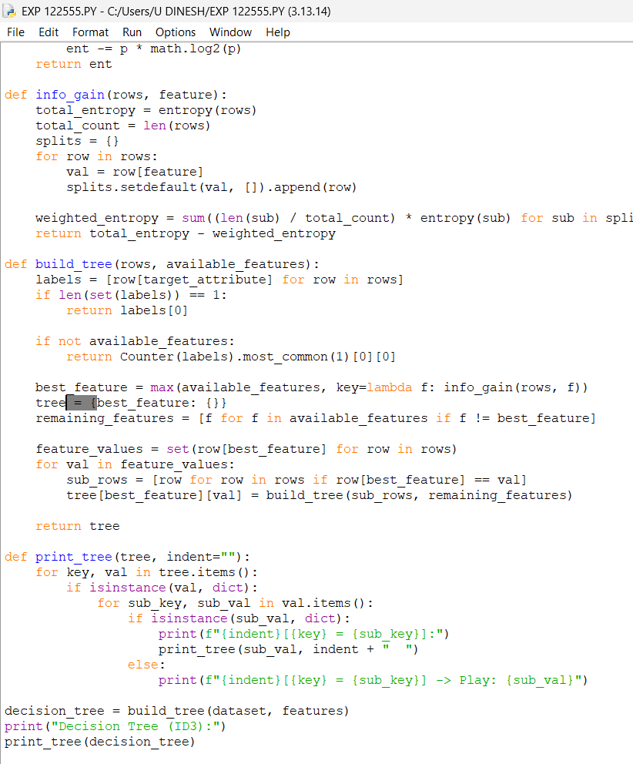

OUTPUT:
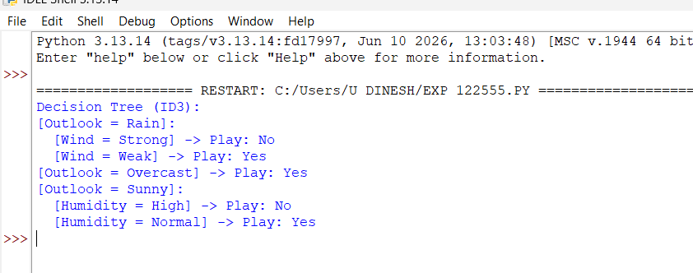

RESULTS:
Decision Tree: The decision tree is constructed and used to predict the output based on the input data.

